## Mumbai Dabbawalla.

**A Project Report**

Submitted in partial fulfillment of the Requirements for the award of the Degree of

**BACHELOR OF SCIENCE (INFORMATON TECHNOLOGY)**

**By**

Punit Rakesh Mistry

533

**Under the esteemed guidance of**

**Ms. Anisha Ma’am**

##### **Assistant Professor**

##### 

**NAGINDAS KHANDWALA COLLEGE(Autonomous)**

***(Affiliated to University of Mumbai)***

**MUMBAI, 400 064**

**MAHARASHTRA**

**2021-22**

**(Original Copy of the Approved Proforma of the Project Proposal )**

***(Note: All entries of the proforma of approval should be filled up with appropriate and* complete information. Incomplete proforma of approval in any respect will be summarily rejected.)**

PNR **No.: ……………………** Roll no**: 533**

* 1. Name of the Student: Punit Mistry



* 1. Title of the Project: Mumbai Dabbawalla.



* 1. Name of the Guide: Anisha ma’am
  2. Teaching/Industry experience of the Guide:
  3. Is this your first submission? Yes

Signature of the Student: Signature of the Guide:

Date: ………………… Date: …………………….

Signature of the Coordinator:

Date: ………………

**NAGINDAS KHANDWALA COLLEGE(Autonomous)**

***(Affiliated to University of Mumbai)***

**MUMBAI, 400 064**

**MAHARASHTRA**

**DEPARTMENT OF INFORMATION TECHNOLOGY/ COMPUTER SCIENCE.**



**CERTIFICATE**

This is to certify that the project titled, **"Mumbai Dabbawalla "**, is bonafied work of **Punit Mistry** bearing Seat.No: (**533**) submitted in partial fulfillment of the requirements for the award of degree of BACHELOR OF SCIENCE in COMPUTER SCIENCE from University of Mumbai.

**Internal Guide Coordinator**

**(**Don’t write names of lecturers or HOD)

**External Examiner**

**Date: College Seal**

**COMPANY CERTIFICATE (if applicable)**

**Abstract**

The project is aimed to make an awareness about the Mumbai Dabbawalla, this will mean better services, quick search and also paperless environment. This project has mainly tackled management of information for the customers and the order. The admin of the website will have to log into the system using username and password so that security and authentication will be ensured. The main purpose of our website will be to provide an easy and efficient way for customers to buy dabba and admin to maintain the records easily and for a longer period of time and also expanding the business by getting more customers. The customers could order the dabba at their own convenience and also get updated for various offers coming up This will make a great difference for customers and admin. This will help in realizing the vision 2030 where the government wants its people to be digitally informed and all the sector of government and ministries.

**ACKNOWLEDGEMENT**

I want to express my gratitude and appreciation to all those who gave me the possibility to complete this project. A special thanks to my parents and my brother for providing me with my needs and their stimulating support.

I am very thankful to **Dr Mrs. Ancy Jose**, the principal of Nagindas Khandwala College for her kind co-operation in the completion of my project.

I also Thanks **Mrs.** Head of Department of our section in college for supporting me.

I am highly indebted to **Ms. . Anisha Ma’am** for her guidance and constant supervision as well as for providing necessary information regarding the project & also for her support in completing the project.

I am also thankful to our other staff of our department for facilitating me with the necessary requirements and support and co-operation. My project experience was satisfying, fulfilling acknowledge filled lastly, I would like to thank my college Nagindas Khandwala college of commerce, arts and science (autonomous) for providing me with proper ambience and supplying me with the right amenities that has helped me complete this project on time and satisfyingly.

### DECLARATION

### Content

I hereby declare that the project entitled, “**Mumbai Dabbawala** ” done at **place where the project is done**, has not been in any case duplicated to submit to any other university for the award of any degree. To the best of my knowledge other than me, no one has submitted to any other university.

The project is done in partial fulfillment of the requirements for the award of degree of

**BACHELOR OF SCIENCE (INFORMATON TECHNOLOGY)** to be submitted as final semester project as part of our curriculum.

**Name and Signature of the Student**

**TABLE OF CONTENTS**

CHAPTER 1: INTRODUCTION

1.1 Background

1.2 Objectives

1.3 Applicability

CHAPTER 2: GAP ANALYSIS/ DRAWBACK OF EXISTING SYSTEM

CHAPTER 3: REQUIREMENTS AND ANALYSIS

3.1 Problem Definition

3.2 Requirements Specification

3.3 Planning and Scheduling

3.4 Software and Hardware Requirements

3.5 Preliminary Product Description

CHAPTER 4: SYSTEM DESIGN

4.1 Basic Modules

4.2 Schema Design

4.3 UML Diagrams / Block Diagram/ Circuit Diagram/ Algorithms Design

4.4 User interface design

4.5 Security Issues

CHAPTER 5: IMPLEMENTATION AND TESTING

5.1 Code (Place Core Segments)

5.2 Testing Approach and Test Cases

CHAPTER 6: RESULTS AND DISCUSSION

6.1 Test Reports

6.2 User Documentation

CHAPTER 7: CONCLUSIONS

7.1 Conclusion

7.1.1 Significance of the System

7.2 Limitations of the System

7.3 Future Scope of the Project

REFERENCES

**CHAPTER 1: INTRODUCTION**

1.1 Background

In today’s age of fast food and take-out, many restaurants have chosen to focus on quick preparation and speedy delivery of orders rather than offering a rich dining experience. Until very recently, all of these delivery orders were placed over the phone, but there are many disadvantages to this system, including the inconvenience of the customer needing to have a physical copy of the menu, lack of a visual confirmation that the order was placed correctly, and the necessity for the restaurant to have an employee answering the phone and taking orders.

The main advantage of my system is that it greatly simplifies the ordering process for both the customer and the restaurant. When the customer visits the ordering webpage, they are presented with an interactive and up-to-date menu, complete with all available options and dynamically adjusting prices based on the selected options. After making a selection, the item is then added to their order, which the customer can review the details of at any time before checking out. This provides instant visual confirmation of what was selected and ensures that items in the order are, in fact, what was intended.

This system also greatly lightens the load on the restaurant’s end, as the entire process of taking orders is automated. Once an order is placed on the webpage, it is entered into the database and then retrieved, in pretty much real-time, by a desktop application on the restaurant’s end.

1.2 Objectives

* To give the desired recognition to *Mumbai Dabbawalas*.
* To gain confidence amongst the people that the delivery persons “dabbawalas” are trustworthy and follow all the necessary guidelines of cleanliness.
* To make the ordering more user friendly and easy to use.
* To design a system that can handle a large number of orders at a time.
* Placing the order in few clicks, at one’s convenient timings.

1.3 Applicability

My system will allow restaurants to quickly and easily manage an online menu which customers can browse and use to place orders with just a few clicks. The system then relays these orders to restaurant employees through an easy to navigate graphical interface for efficient processing.

**CHAPTER 2: GAP ANALYSIS**

* Promotional and branding aspect of the system.
* The equipment and technology.
* Investment needed for the product/system.
* Lesser reach as compared to current food delivery applications and websites like Zomato, Swiggy , Foodpanda , etc.
* Delivery options available for limited locations. Also, not delivery outside Mumbai .
* Delivery option available during working hours only and not 24 hours.

**CHAPTER 3: REQUIREMENTS AND ANALYSIS**

* 1. Problem Definition
* The dabba/tiffin services has turned out to be very helpful for all the career oriented people.
* Proven to be very convenient for people working in night shifts.
* Day by day people are moving out into different cities and PG culture is increasing, the dabba services have been very helpful for them also this services is very budget friendly.
* This encourages many small businesses.
* Gives multiple opportunities to businesses and job opportunities for many people. It offers jobs like delivery, cooking, site maintenance and many more

3.2 Requirements Specification

* All possible requirements of the system to be developed are captured in this phase and documented in a requirement specification doc.
* The requirement specifications from first phase are studied in this phase and system design is prepared. System Design helps in specifying hardware and system requirements and also helps in defining overall system architecture.
  1. Planning and Scheduling
* Deployment of system: Once the functional and Non functional testing is done, the product is deployed in the customer environment or released into the market.
* Maintenance: There are some issues which come up in the client environment. To fix those issues patches are released. also to enhance the product some better versions are released. Maintenance is done to deliver these changes in the customer environment.

3.4 Software and Hardware Requirements

Software Requirements:

* Windows Xp, Windows 7, windows 10
* Sql 2008
* Visual studio 2010
* PHP

Hardware Requirements:

* Processor – i3
* Hard Disk – 5 GB
* Memory – 1GB RAM

3.5 Preliminary Product Description

As the goal of the system is to make the process of placing an order as simple as possible for the customer, the functionality provided through the web ordering system is restricted to that which most pertinent to accomplish the desired task.

**CHAPTER 4: SYSTEM DESIGN**



4.2 Schema Design

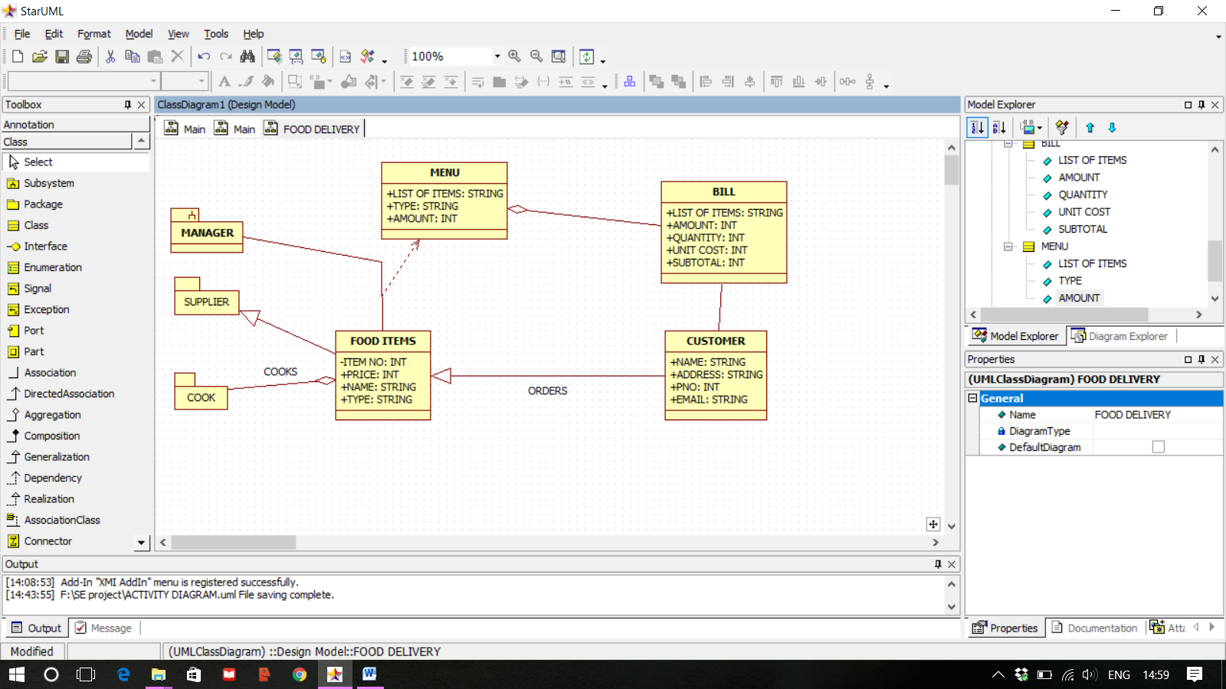

4.3 UML Diagrams / Block Diagram/ Circuit Diagram/ Algorithms Design

UML Diagrams :

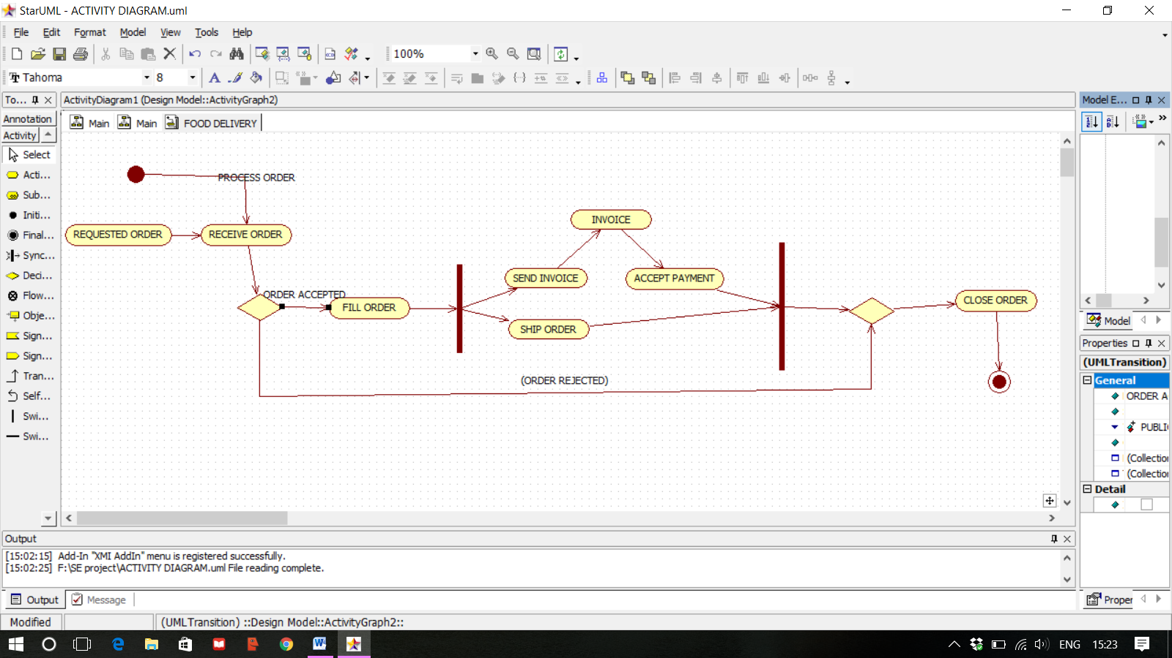

Block Diagram :-

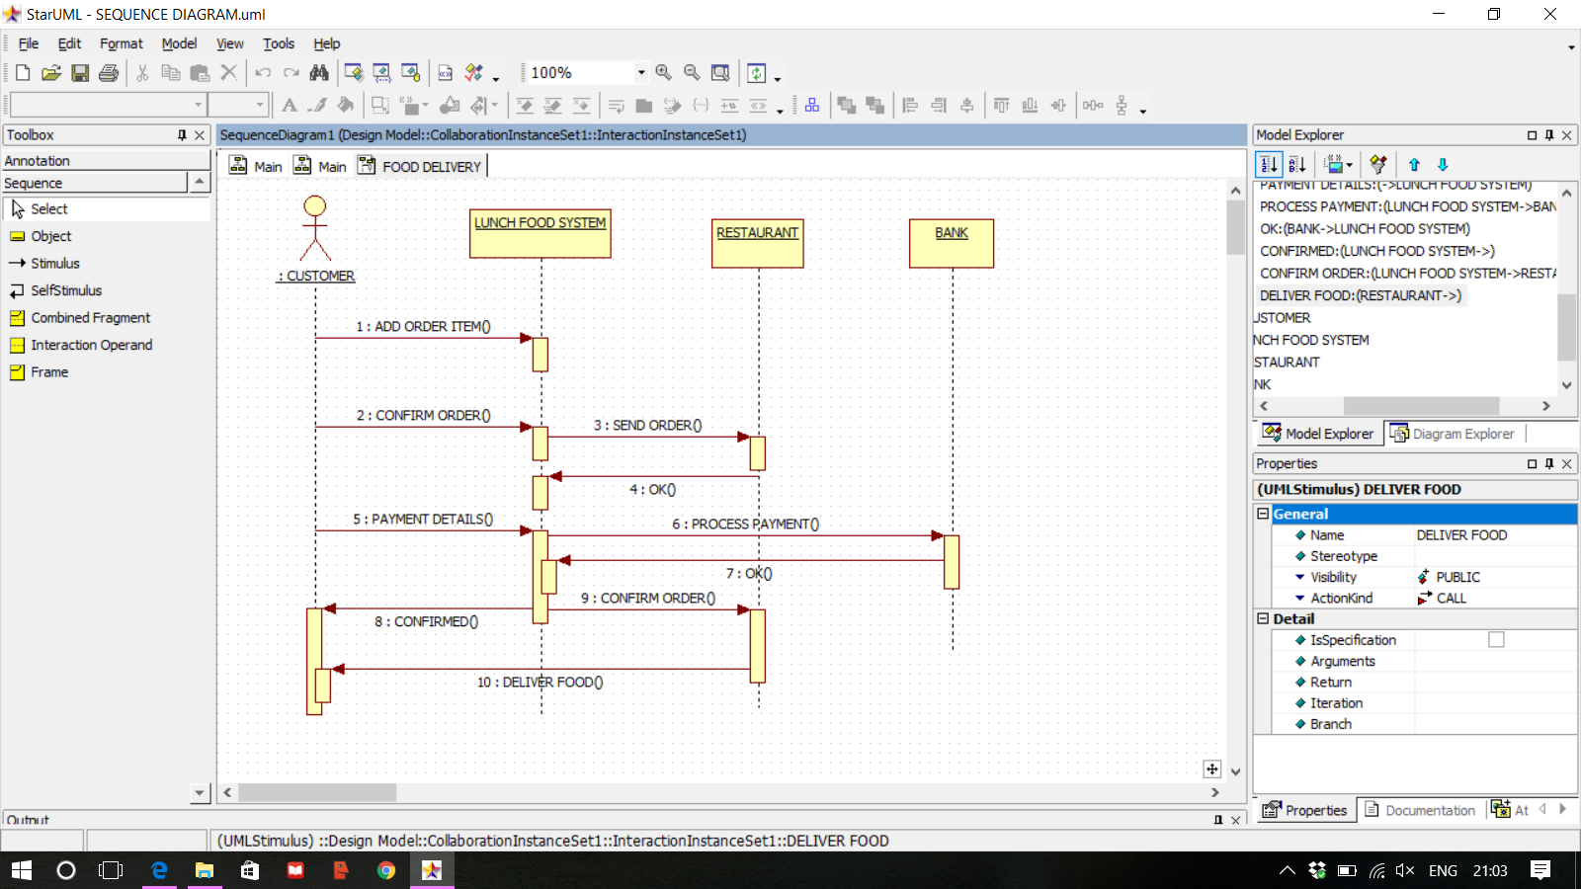

Algorithm :-

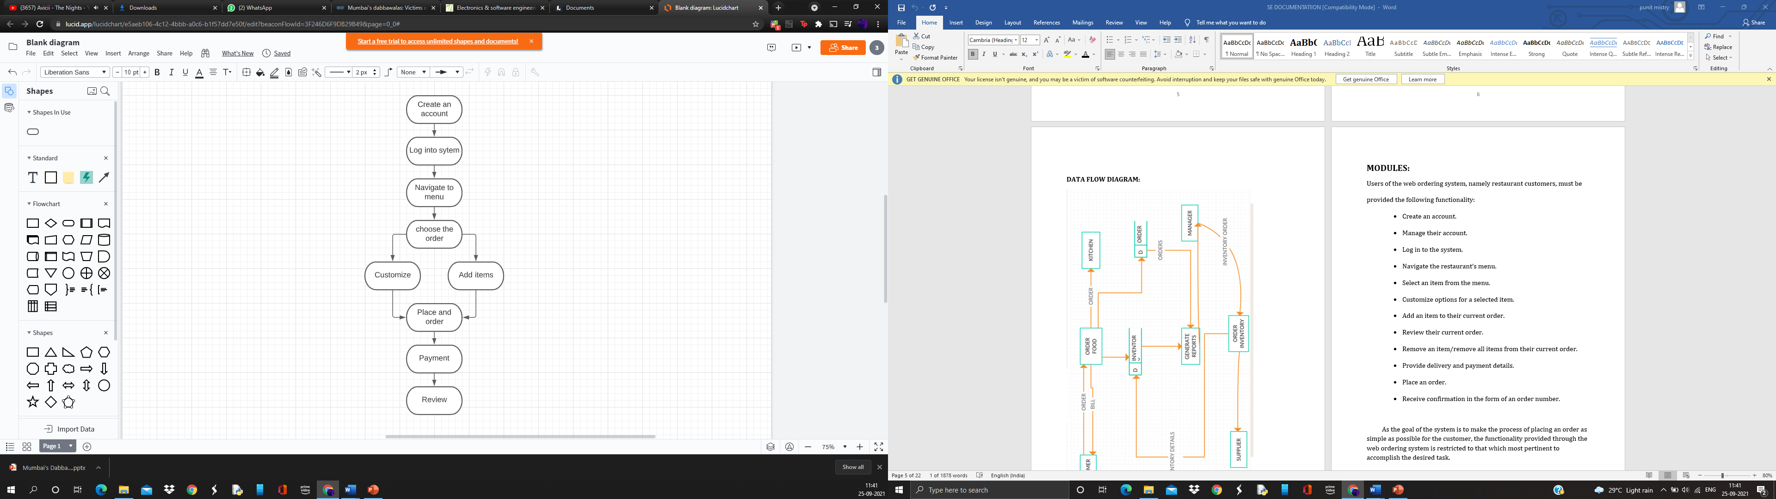

Gantt chart :

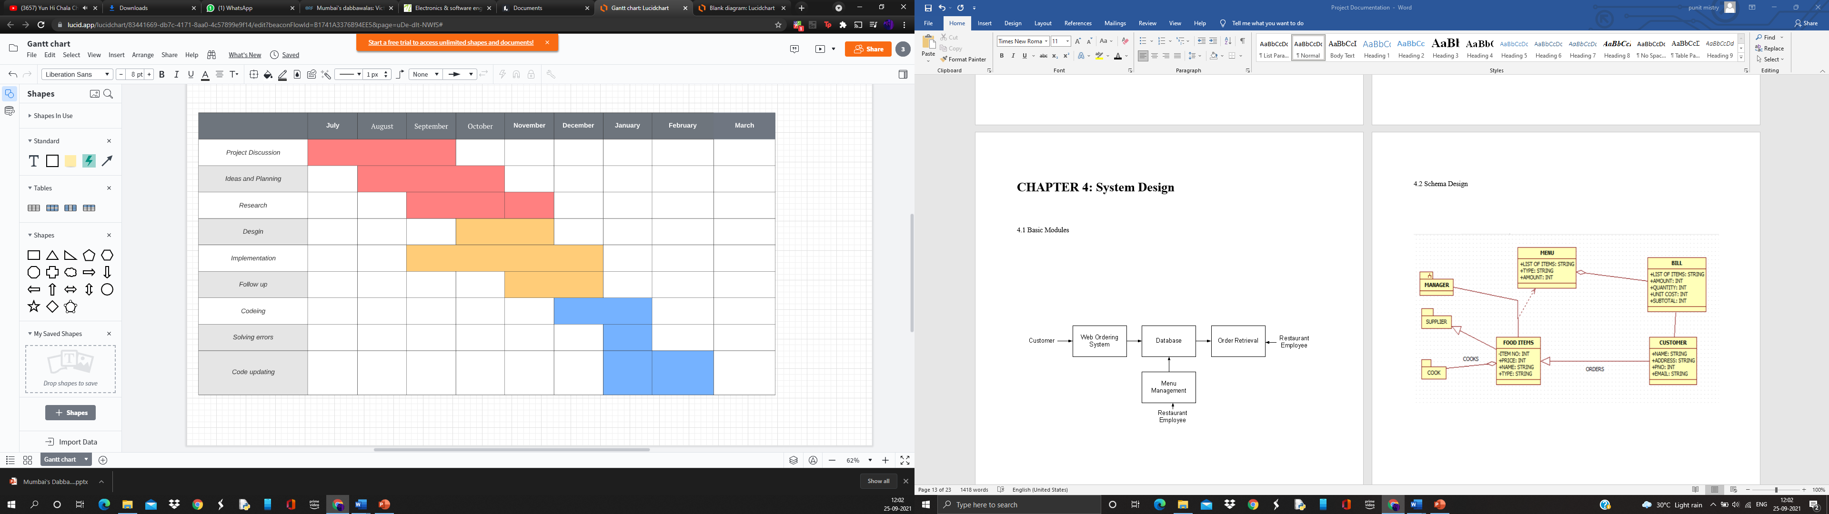

4.4 Security Issues

# COVID – 19: due to covid 19 many dabbawalla have been victims of covid 19 due to which collateral damage have been done to many people Following the death of Santosh Jadhav, a dabbawalla, to Covid-19 on 24 June.

**CHAPTER 5: IMPLEMENTATION AND TESTING**

5.1 Code (Place Core Segments)

5.2 Testing Approach and Test Cases

**CHAPTER 6: RESULTS AND DISCUSSION**

6.1 Test Reports

6.2 User Documentation

**CHAPTER 7: CONLUSIONS**

7.1 Conclusion

Within this application, all items in the order are displayed, along with their corresponding options and delivery details, in a concise and easy to read manner. This allows restaurant employees to quickly go through the orders as they are placed and produce the necessary items with minimal delay and confusion.

Overall, we have created application in focus of future ONLINE FOOD ORDERING SYSTEMS, this application will be helpful to many people.

7.2 Future Scope of the Project

* Order via virtual assistants like chatbots and whatsapp bots.
* Having the option to place the order for complete week with different orders/food items.
* Reducing the customer journey i.e. reducing the details taken from users.
* Making improvements in UI/UX of the system.
* Having the tracking option.

**REFERENCES :**

* <https://mumbaidabbawala.in/>
* <https://www.google.com/>
* <https://www.w3schools.com/>
* <https://en.wikipedia.org/wiki/Online_food_ordering/>